# Project 2 CS 340 README

## About the Project/Project Title

This project is developed for Grazioso Salvare, a company that specializes in training rescue dogs for life saving operations. The application uses data from five animal shelters around Austin, Texas, provided by a non-profit agency. This system features a MongoDB database to store animal records, a Python CRUD module to manage this data, and a dashboard with interactive features. Users of this application can filter animals by the type of search and rescue operation, view a pie chart of outcome types for listed animals, and view a geolocation map showing the location of the selected animal. The goal of this application is to help Grazioso Salvare efficiently identify suitable dogs for search and rescue training.

## Motivation

This project was developed to quickly identify dogs that meet the criteria for search and rescue training. By analyzing data from local animal shelters, Grazioso Salvare can effectively select dogs suited for various tasks such as water rescue, mountain or wilderness rescue, disaster rescue and scent tracking. Additionally, by making the project open source, Grazioso Salvare hopes to help other organizations by providing them with the tools to enhance their own rescue operations.

## Getting Started

To get a local copy up and running, follow these simple example steps:

1. Open the Terminal to work with MongoDB. Locate the CSV file by finding the directory and filename. Use the mongoimport tool to upload data from a CSV file. Once the command is executed, MongoDB will process the CSV file and import the data into the AAC database under the animals collection. You will see output in the terminal indicating the number of records that were successfully imported as shown below:

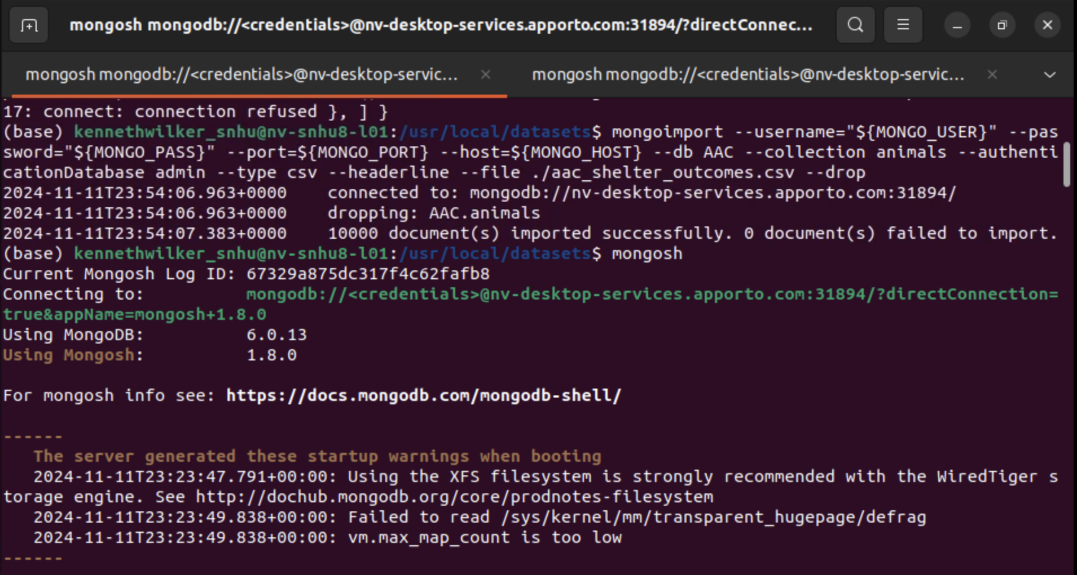

2) Create a new user with the name and password of your choice for the AAC database using the MongoDB shell. You will need to create the user in the admin database but assign it roles for the AAC database. Ensure that your new user is given the appropriate roles (such as readWrite) to allow access and modifications in the AAC database as shown below: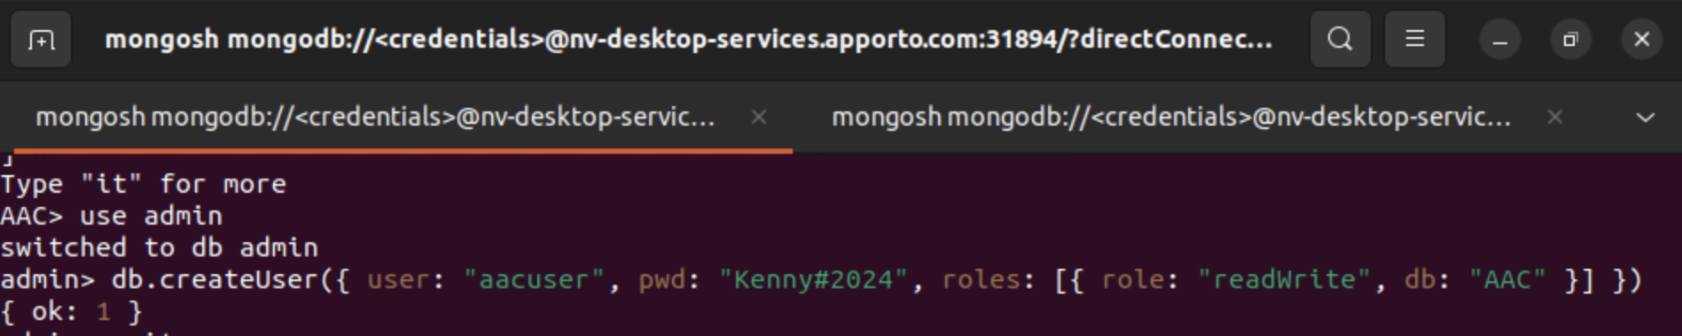

3) To log in as your newly created user, you need to set two environment variables: MONGO_USER and MONGO_PASS. First, MONGO_USER should be set to the username you created (in this case, aacuser), and MONGO_PASS should be set to the password you assigned to that user (in this case, Kenny#2024). To do this, open a new terminal window and set the variables using the following commands:

export MONGO_USER=yourusername

export MONGO_PASS=yourpassword

Once the environment variables are set, open the MongoDB shell by typing mongosh in the terminal. MongoDB will automatically use the credentials specified by the environment variables for authentication. After logging in, to verify that you are successfully logged in as the correct user with the proper roles, run the following command:

db.runCommand({connectionStatus: 1})

This command will display connection details, including the authenticated username and roles assigned to that user as shown below: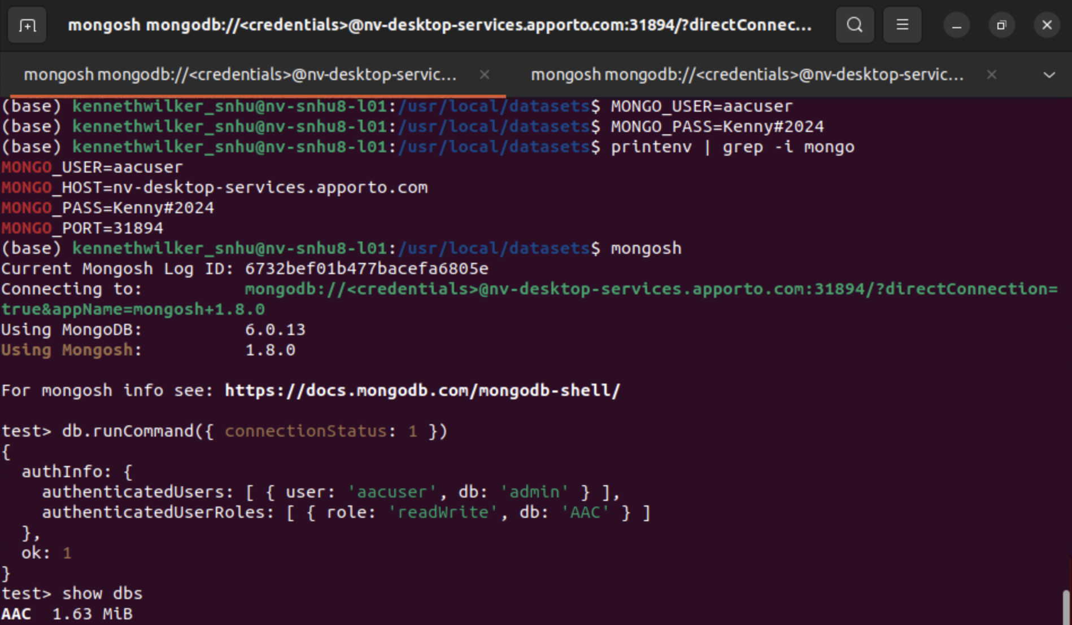

4) Open a Terminal and type the following command to see if Python is currently installed:

python —version

Also, check to see if Jupyter Notebook is installed by typing the following command:

jupyter —version

If you do not have Python and/or Jupyter installed you will need to install it using the Python and Jupyter websites provided in the Installation section. If they are installed, you will see a version number displayed as shown below: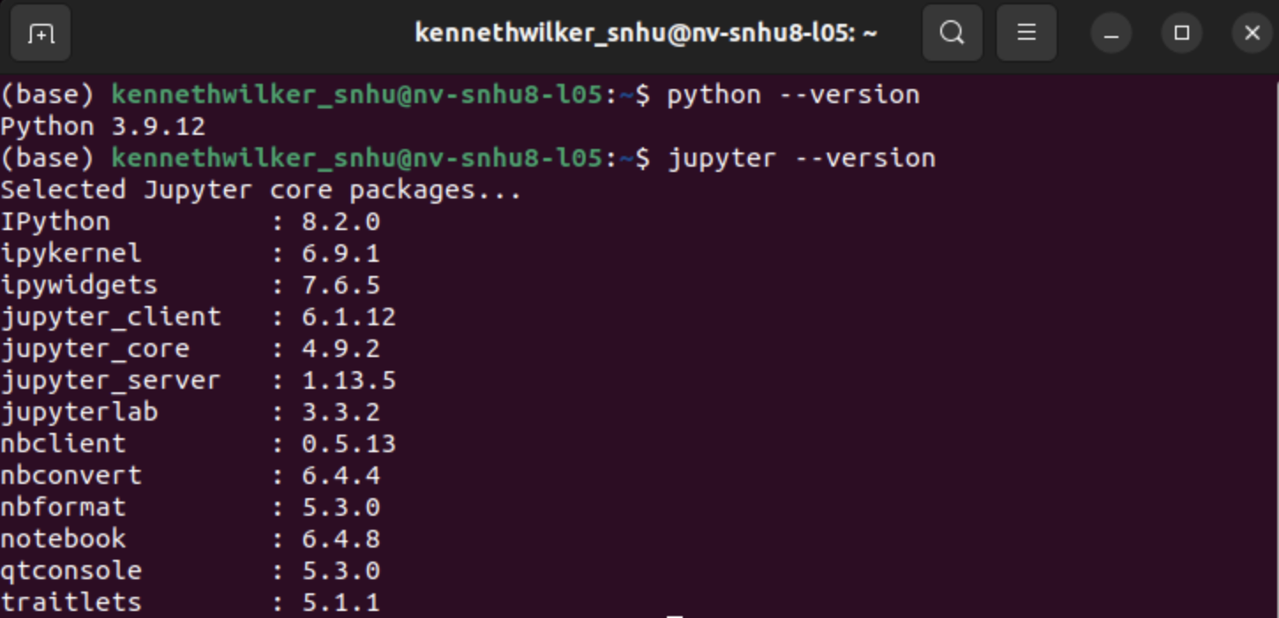

5) Once your CRUD module is completed, open up a Jupyter Notebook file to create your interactive data table and geolocation chart. The data table will initially start out with an unfiltered view of the Austin Animal Center Outcomes data.

The code provided below outlines the development of the interactive data table:

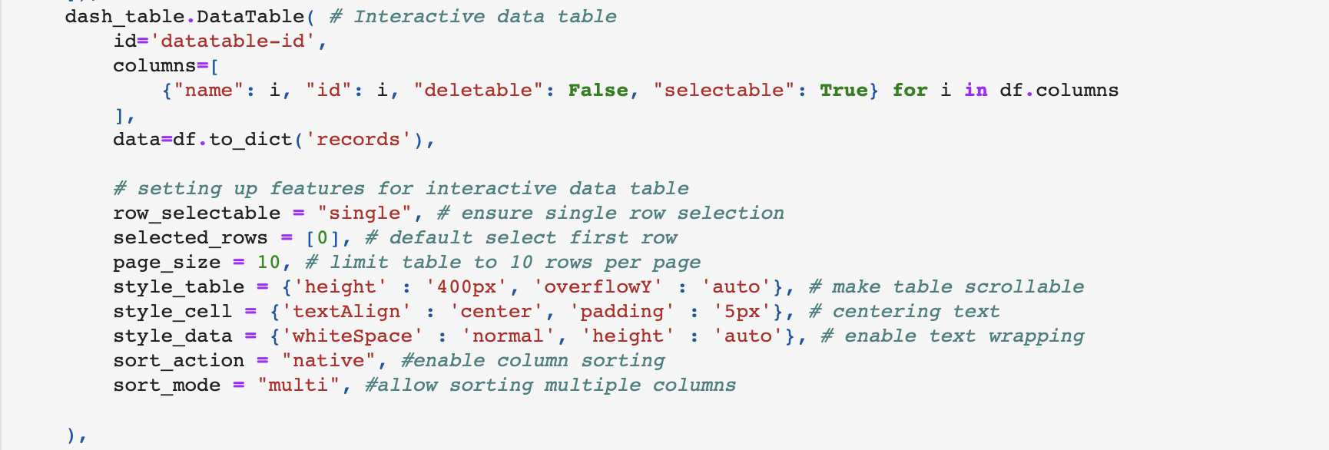

## Additionally, below is the code used to create the geolocation map:

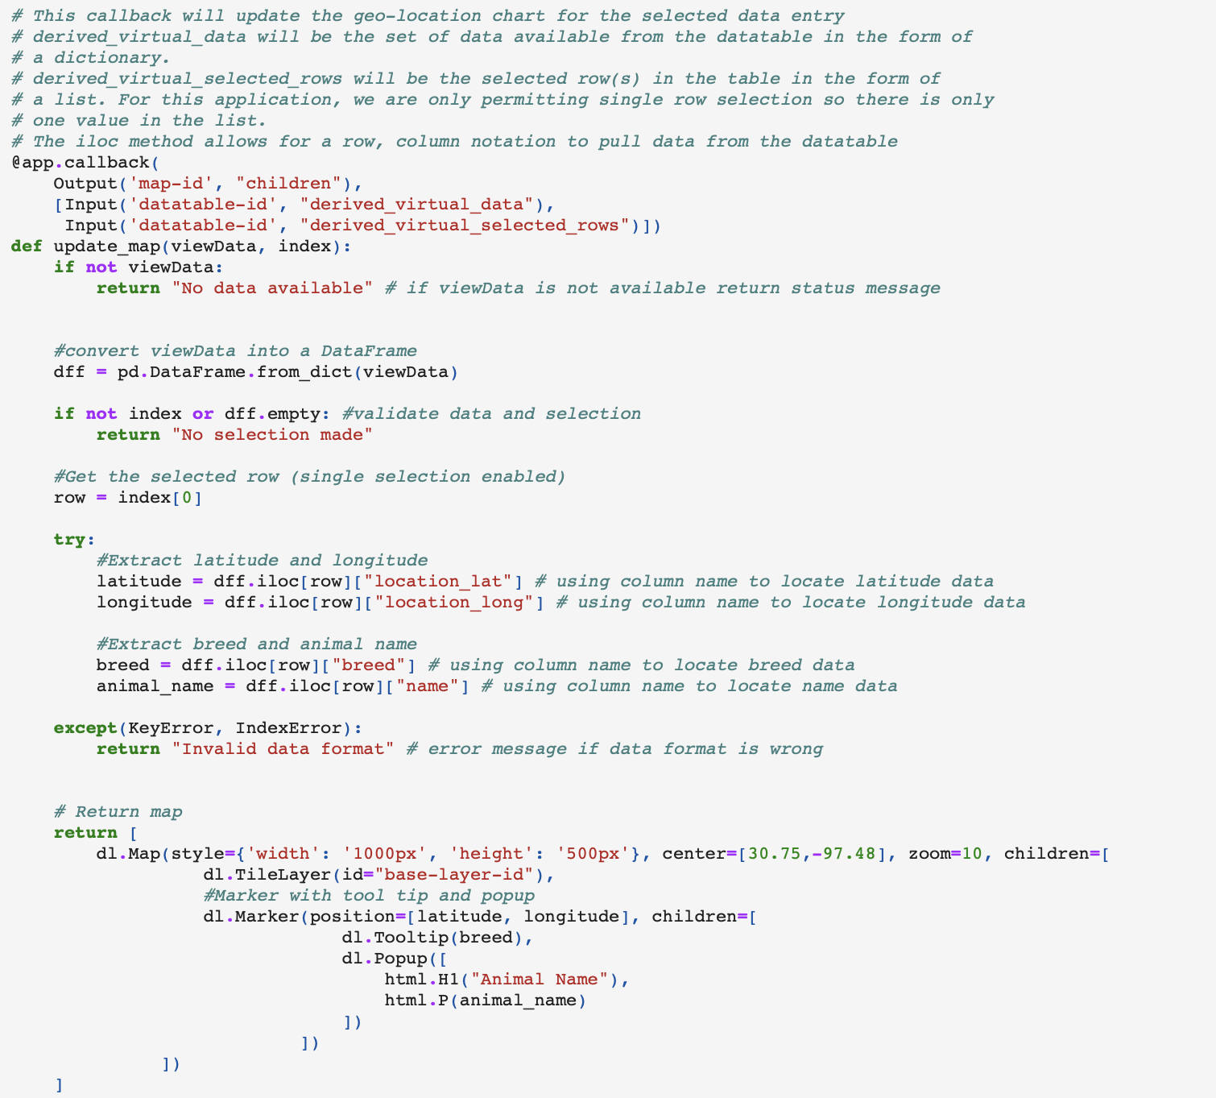

6) Once you have a basic data table and a geolocation map that updates based on the selected animal, you can enhance your dashboard by adding additional features. This project includes radio buttons for filtering data, as well as filter queries designed to retrieve preferred dog breeds based on criteria such as sex and training age. These features help streamline the selection process. Additionally, a pie chart is included to visualize the outcome types of the animals in the data table.

This is the code responsible for creating the radio buttons:

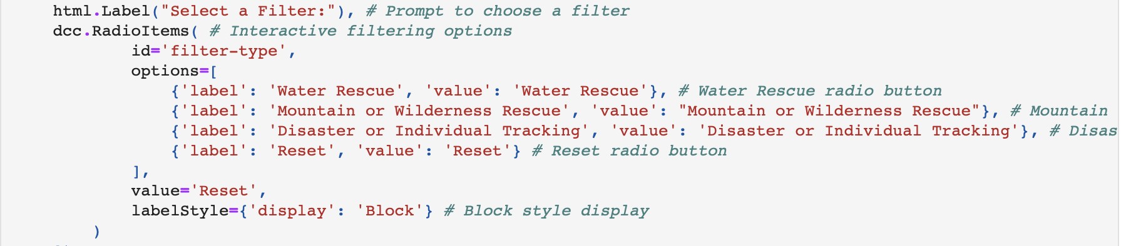

This is the code containing the logic for the filter queries:

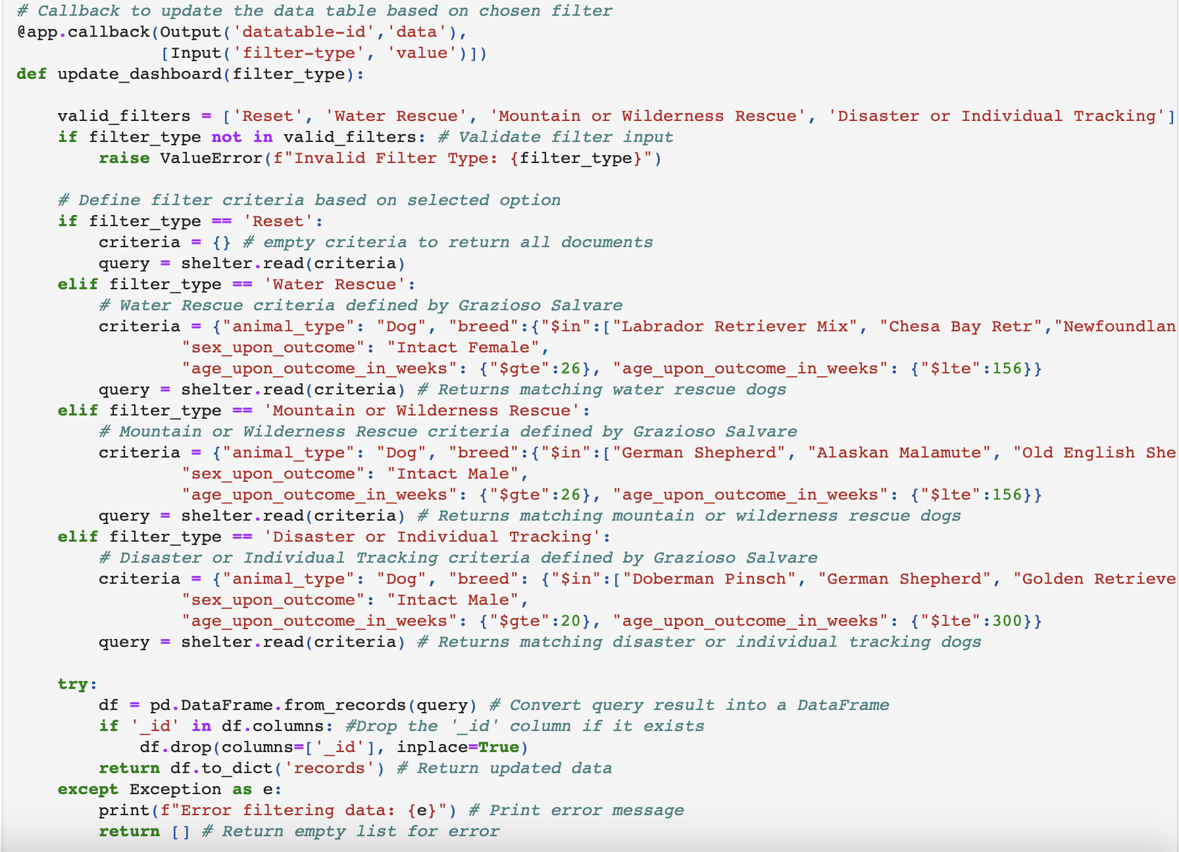

Here is the code that generates the pie chart to display the outcome types of the animals in the data table. The pie chart updates dynamically when the data is filtered:

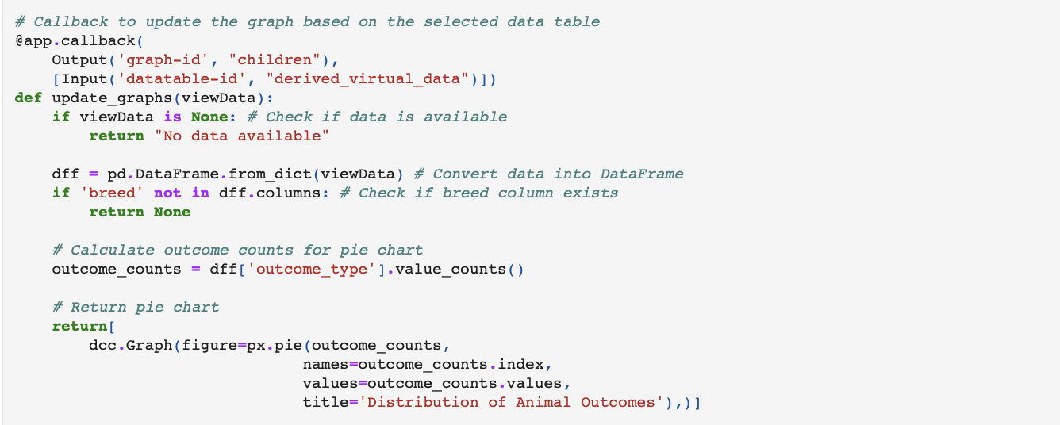

## Installation

Tools:

* + - MongoDB 8.0: https://www.mongodb.com/try/download/community
    - Jupyter Notebook 7.2: https://jupyter.org/install
    - Python 3.13: https://www.python.org/downloads/
    - Dash 2.18.2 https://dash.plotly.com/

Libraries:

* + - pymongo
    - bson.objectid
    - plotly.express
    - base64
    - os
    - numpy
    - pandas
    - matplotlib.pyplot

## Explanation of Tools

## MongoDB was chosen for its document based structure, which allows storing animal records in a flexible format. It is well-suited for efficiently querying large datasets, which is crucial for handling animal records from multiple shelters. The incorporation of PyMongo facilitated seamless communication between the database and the Python application. The Dash framework was useful because it integrates the view and controller components of the application. It is a Python framework that simplifies the development of web applications by allowing developers to use Python for backend and frontend development. Dash’s callback functions allow for dynamic updates of visual elements such as the pie chart and geolocation map based on user input. This ensures an interactive experience for the user. In this context, plotly and pandas were very useful. Plotly enabled interactive data visualizations and pandas provided effective data manipulation capabilities. Altogether, these tools provided an interactive and user-friendly dashboard for the end user. For more details, links to the tools described are provided in the Installation section.

## Usage

* c*lass AnimalShelter (object): This class manages CRUD operations for the animals collection in the AAC database on MongoDB. It provides methods for efficiently creating, reading, updating and deleting animal records.*
* *def __init__(self, username, password): This method initializes a MongoClient instance and establishes a connection to the MongoDB server using the provided username and password for authentication. It connects specifically to the AAC database and accesses the animals collection within it. Once connected, this allows the application to perform CRUD (Create, Read, Update, Delete) operations on the data in the animals collection.*
* *def create(self, data): This method adds a new animal record to the database. It takes data and attempts to insert it into the animals collection. If the insertion is successful, it returns True; if it is not successful, it returns False.*
* *def read(self, pair): This method performs a search in the database using the provided key/value attribute pair, returning a list of animals that match the specified criteria. If there are no matches, an empty list is returned.*
* *def update(self, pair, update_data, multiple=False): This method updates one or more documents in the collection based on a specified filter. If multiple is set to True, the method updates all matching documents. If multiple is set to False, the method updates only the first matching document. This method also returns the number of documents updated. An unsuccessful update returns 0.*
* *def delete(self, pair, multiple=False): This method deletes one or more documents in the collection based on a specified dictionary. If multiple is set to True, the method deletes all matching documents. If multiple is set to False, the method deletes only the first matching document. This method also returns the number of documents deleted. An unsuccessful deletion returns 0.*

### Screenshots

Click the Reset button for an unfiltered data table of animals:

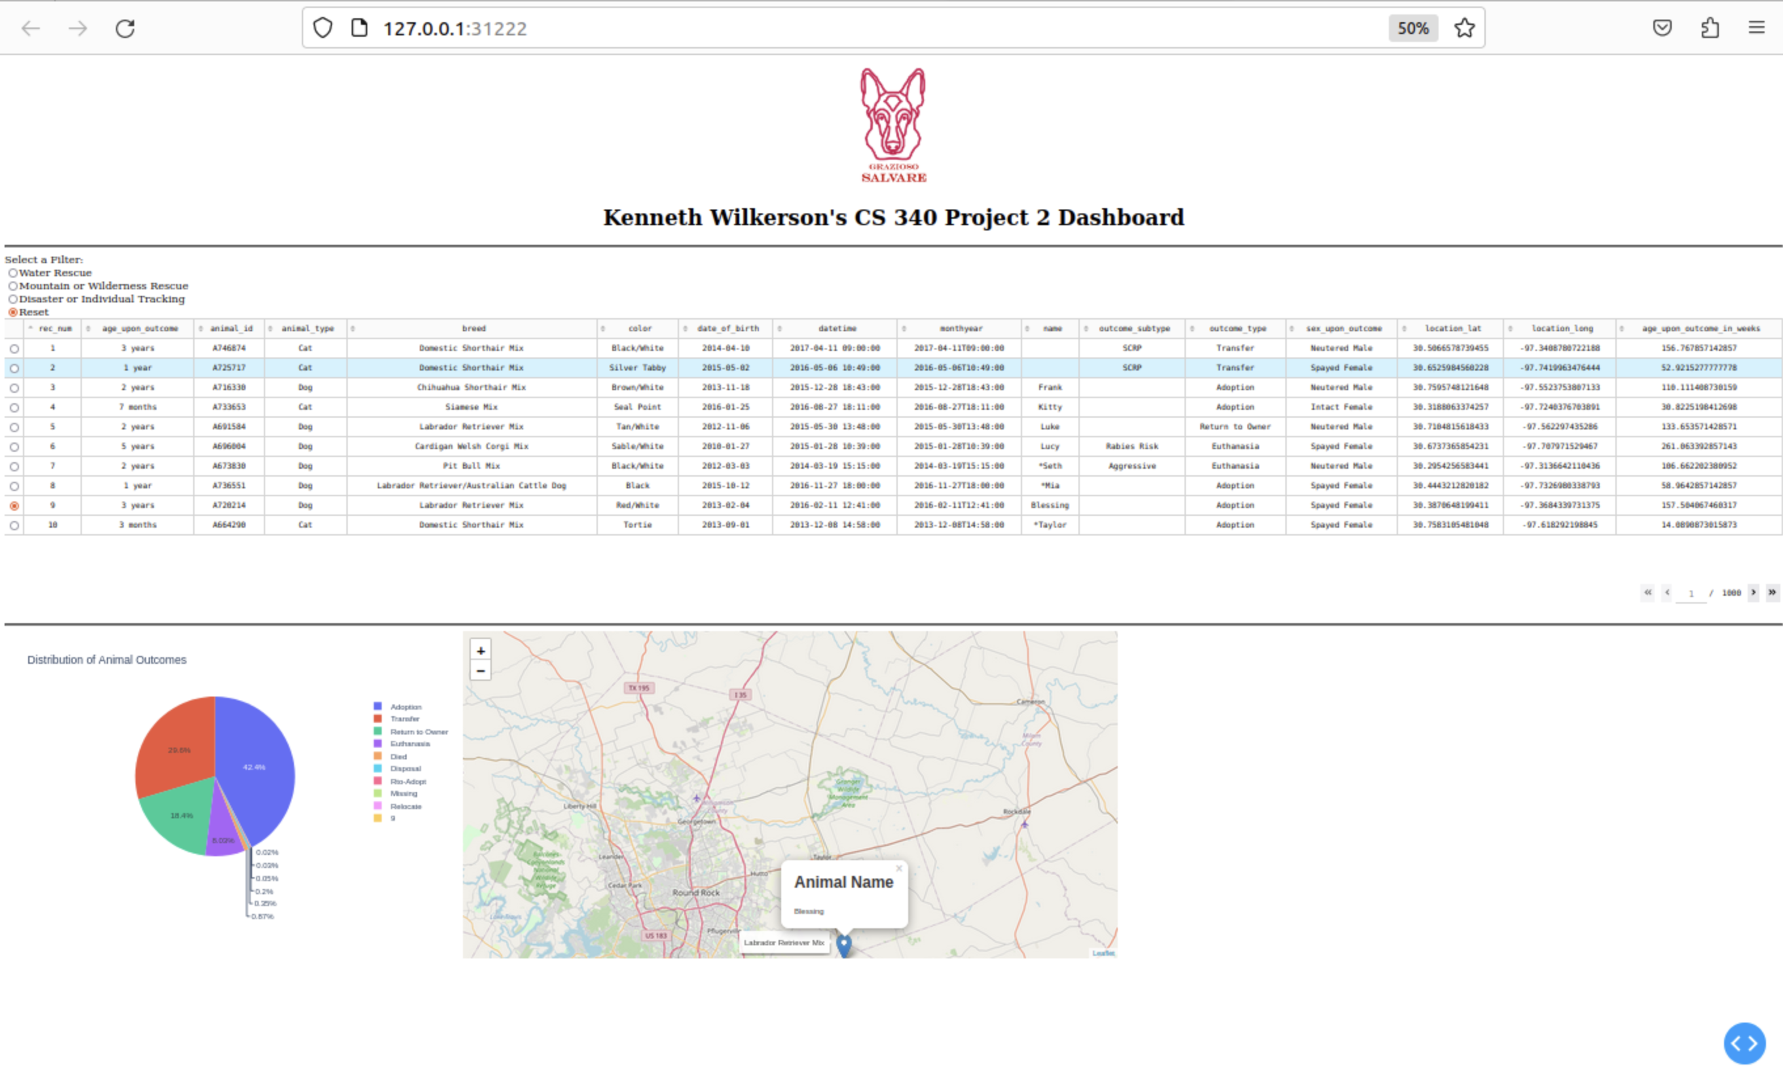

Click the Water Rescue button to filter the data table for dogs suitable for this mission:

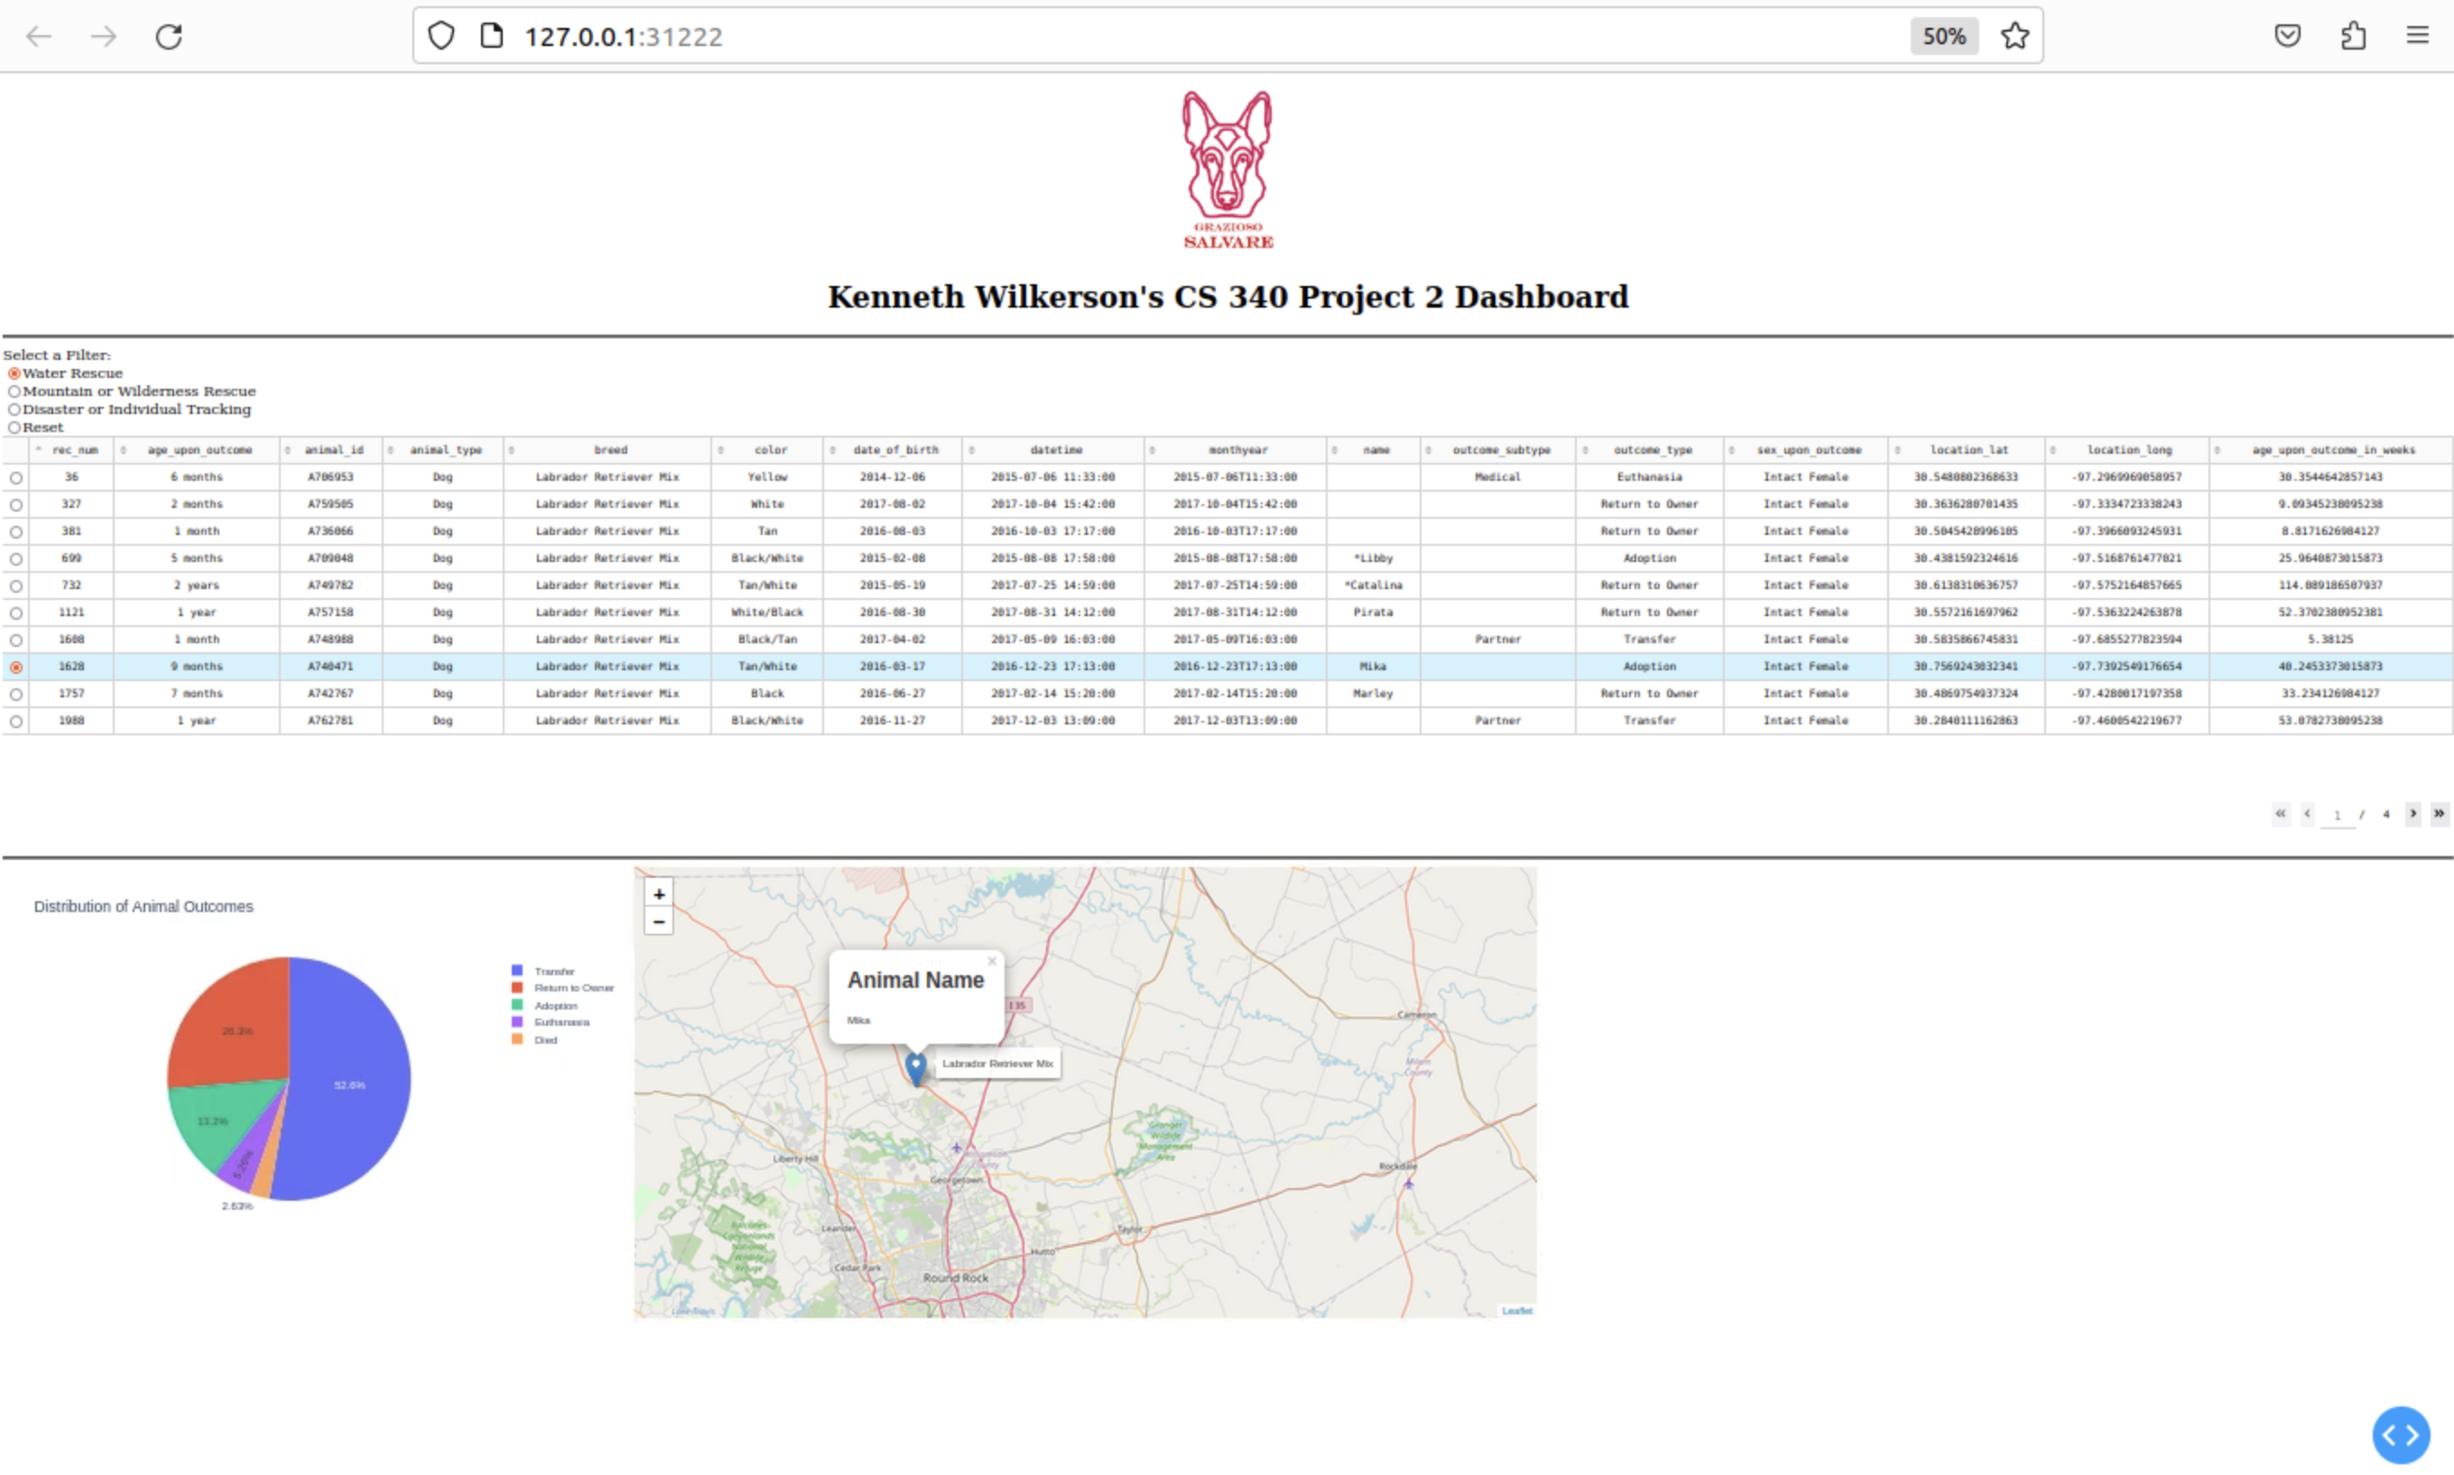

Click the Mountain or Wilderness Rescue button to filter the data table for dogs suitable for this mission:

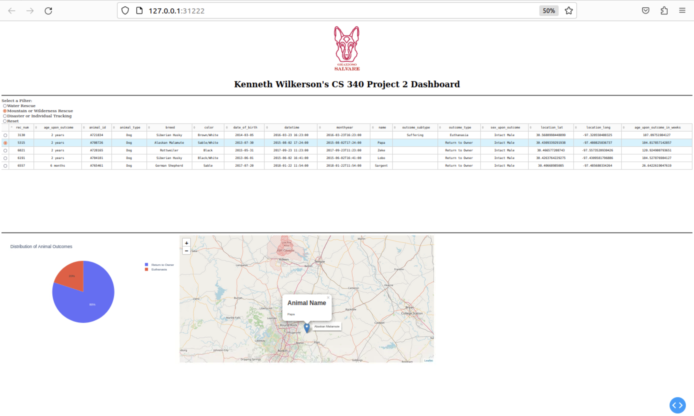

Click the Disaster or Individual Tracking button to filter the data table for dogs suitable for this mission:

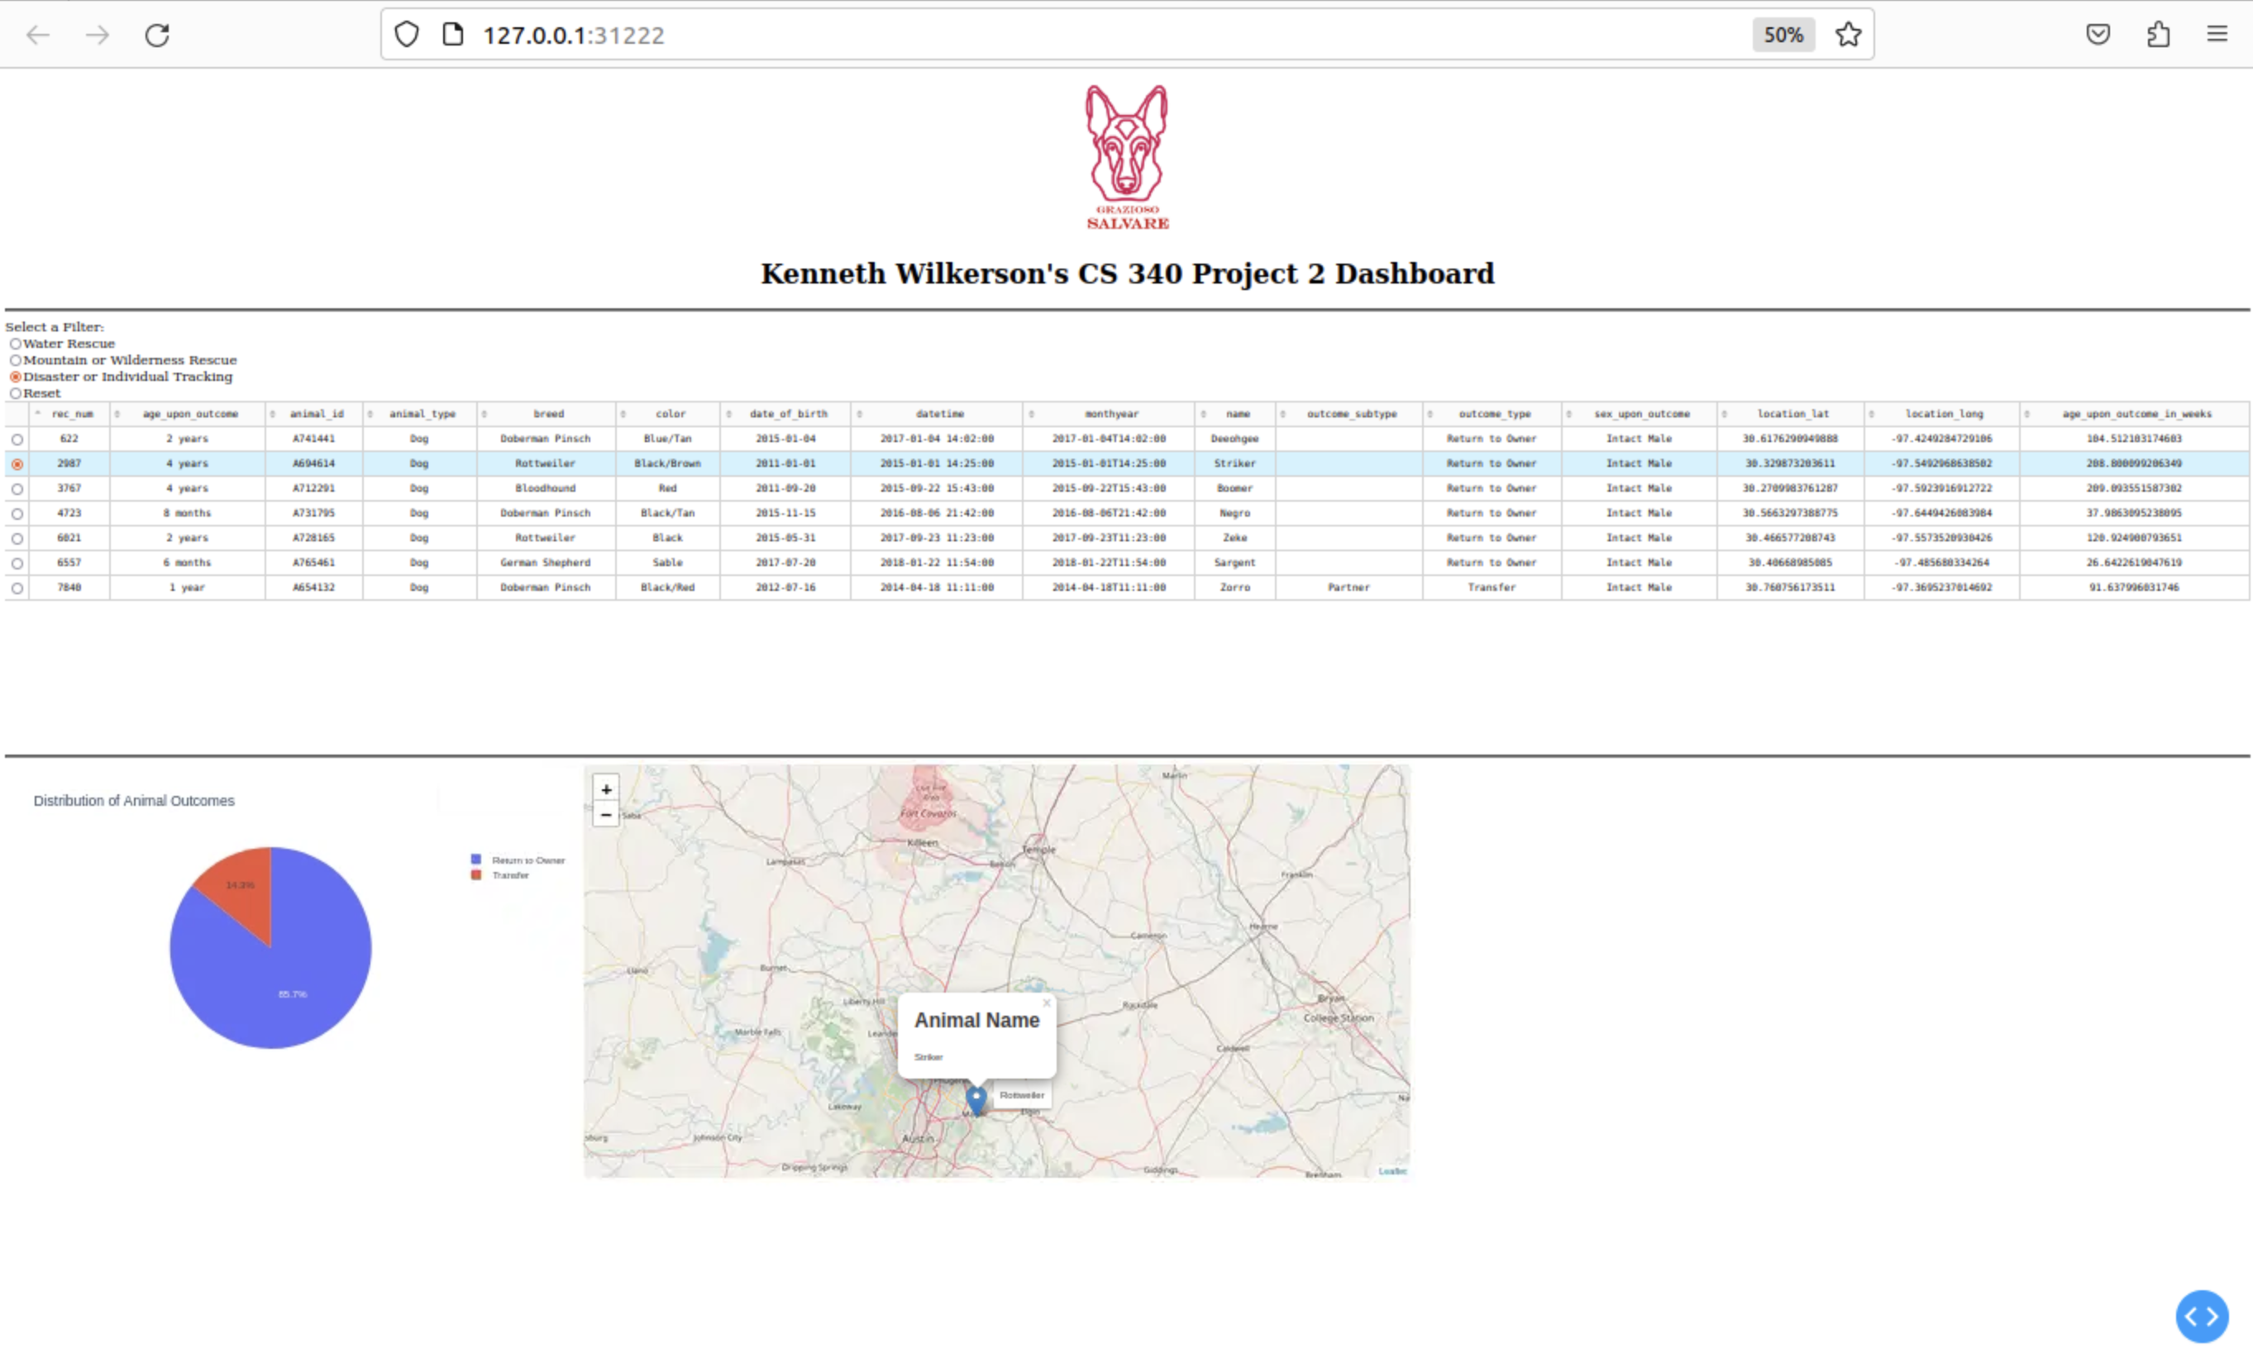

Watch the following screencast to see how the dashboard operates in action. This video demonstrates how users can interact with the application, use the filtering options, and visualize the data in real-time.

Link: <https://www.youtube.com/watch?v=JJrcTNJKqic>

## Roadmap/Features

* Mobile App Version: A mobile version of the application could be developed for easier access to the dashboard and database features, allowing users to interact with animal documents on the go.
* Additional Filters: As search and rescue missions expand, the variety of criteria used to select dogs for training will likely evolve. Therefore, additional filters will be needed to handle this growing complexity.
* Notification/Alerts: The application could include SMS notifications to alert users about important events, such as when new documents are added or when a dog meets specific training criteria to ensure timely updates and action.

**Challenges**

* One issue was with implementing the search and rescue criteria for filtering data from the Austin Animal Shelter. For instance, in the Grazioso Salvare requirements, one breed was listed as “Chesapeake Bay Retriever,” while in the dataset it appeared as “Chesa Bay Retr.” Similarly, another breed was listed as “Doberman Pinscher” in the requirements, but appeared as “Doberman Pinsch” in the dataset. After carefully reviewing the documents, I was able to ensure the filters worked as intended.
* I also struggled with the filtering logic itself, which I resolved by removing the “_id” column from the query results to align with the initial data table.
* Additionally, I occasionally ran into errors when rerunning the Jupyter Notebook, which I was able to fix by stopping the kernel and clearing old outputs.

**Contact**

Your name: Kenneth Wilkerson

Email: kenneth.wilkerson2@snhu.edu